EXPERIMENT 14
Perspective Transformation Using Python and OpenCV
Aim:
To perform Perspective Transformation on an image using Python and OpenCV.
Procedure:
- Import OpenCV and NumPy libraries.
- Read the input image.
- Define the source and destination points.
- Calculate the transformation matrix using cv2.getPerspectiveTransform().
- Apply transformation using cv2.warpPerspective().
- Display the original and transformed images.
Program:
import cv2
import numpy as np

img = cv2.imread('image.jpg')
h, w = img.shape[:2]

pts1 = np.float32([[0,0], [w,0], [0,h], [w,h]])
pts2 = np.float32([[50,50], [w-50,0],
[0,h-50], [w-50,h-50]])

matrix = cv2.getPerspectiveTransform(pts1, pts2)
result = cv2.warpPerspective(img, matrix, (w,h))
cv2.imshow('Original Image', img)
cv2.imshow('Perspective Image', result)
cv2.waitKey(0)
cv2.destroyAllWindows()
Input:

Output:
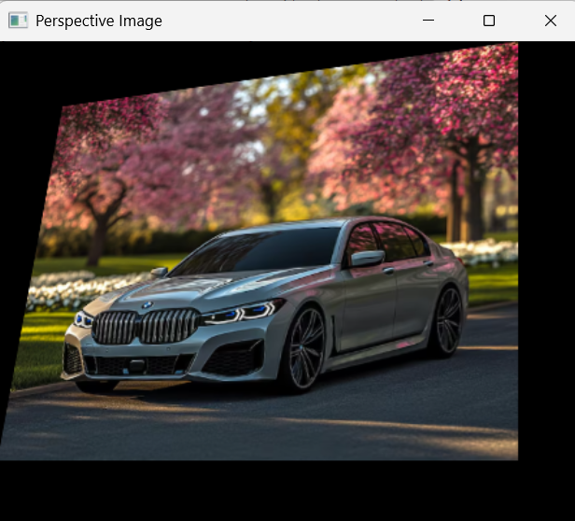

Result:
Thus, Perspective Transformation was successfully performed on the given image using Python and OpenCV.

